# What is SNS in AWS? Types, Pricing, and Configuration

**Amazon SNS (Simple Notification Service)** offered by AWS (Amazon Web Services) is an overseen service that provides message delivery or sending of messages to subscribing endpoints or clients. It is a completely controlled messaging service that is highly available, durable, and secure.

* [**What is AWS SNS**](https://k21academy.com/amazon-web-services/amazon-sns/#This_post_will_cover_everything_that_you_need_to_understand_about_Amazon_SNS)
* [**Features**](https://k21academy.com/amazon-web-services/amazon-sns/#Amazon_SNS_stands_for_Simple_Notification_Service_which_is_utilized_to_convey_the_push_messages_from_the_application_to_the_subscribing_ends_or_other_applications_It_is_a_completely_managed_messaging_service_for_both_application_to_application_A2A_and_application_to_person_A2P_communication_It_provides_the_ability_to_create_a_Topic_that_is_a_logical_access_point_and_communication_channel_Each_topic_has_a_different_name_that_identifies_the_SNS_endpoint_for_publishers_to_post_messages_and_subscribers_to_register_for_notifications)
* [**Types of AWS SNS Topics**](https://k21academy.com/amazon-web-services/amazon-sns/#SNS_Email_Messages_Amazon_SNS_provides_the_features_to_send_text_messages_and_email_SMTP)
* [**Amazon SNS Clients**](https://k21academy.com/amazon-web-services/amazon-sns/#Difference_between_Standard_and_FIFO_Topic)
* [**Benefits**](https://k21academy.com/amazon-web-services/amazon-sns/#Publishers)
* [**Steps to Configure SNS**](https://k21academy.com/amazon-web-services/amazon-sns/#Simple_Architecture)
* [**AWS SNS Pricing**](https://k21academy.com/amazon-web-services/amazon-sns/#8)
* [**Amazon SNS Security**](https://k21academy.com/amazon-web-services/amazon-sns/#Amazon_SNS_Pricing)

**What is AWS SNS?**

**Amazon SNS** stands for Simple Notification Service, which is utilized to convey the push messages from the application to the subscribing ends or other applications. It is a completely managed messaging service for both applications-to-application (A2A) and application-to-person (A2P) communication. It provides the ability to create a Topic that is a logical access point and communication channel. Each topic has a different name that identifies the SNS endpoint for publishers to post messages and subscribers to register for notifications.

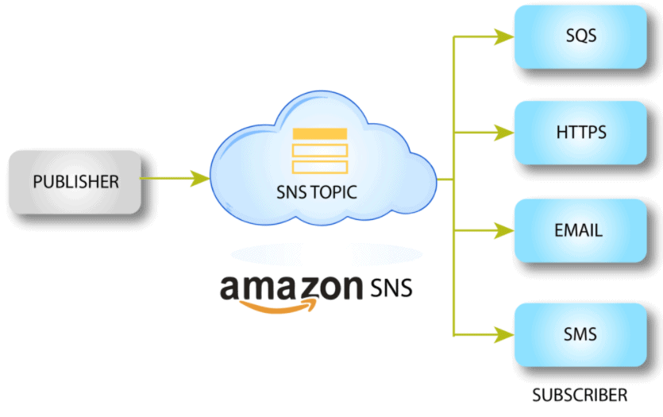

.

**Feature of Amazon SNS**

* **Automatic Scaling:** It scales consequently if the number of messages increases.
* **Message Encryption:** It provides encrypted topics to protect your messages from unapproved and unknown access. The message gets decrypted as they are delivered to subscribing endpoints.
* **Message Filtering:** It enables the subscriber to modify a filter policy so that it only gets the notifications it is interested in.
* **Message Fanout:** It takes place when a message is sent to a topic and then replicated and pushed to multiple endpoints. Fanout gives asynchronous event notifications, which in turn allows for parallel processing.
* **Mobile Notification:** It can be activated by user-driven actions within an application or from business logic within the cloud. It is low-cost to fan out mobile push notifications for iOS, Android, Fire OS, Windows, and Baidu-based devices.
* **SNS & Email Messages:** Amazon SNS provides the features to send text messages and email (SMTP).



Read Our Blog on [**AWS Storage**](https://k21academy.com/amazon-web-services/aws-solutions-architect/aws-storage-overview-types-benefits/)for an overview of and types of storage options offered.

**Types of AWS SNS Topics**

There are 2 types of AWS SNS Topics:

* Standard Topic
* FIFO Topic

**Difference between Standard and FIFO Topic**

* Standard Topic is used in many scenarios where the order of messages is not important while FIFO Topic is used in messaging between applications where the order of operations and events is critical.
* Standard Topic supports a nearly unlimited number of messages per second whereas FIFO Topic supports up to 300 messages per second or 10 MB per second per FIFO topic.
* In a standard topic, a message is delivered at least once, but there might be more than one copy of a message delivered but in a FIFO topic, duplicate messages are not delivered.
* In standard topic, each account can support 100K standard topic and each topic support up to 12.5M Subscriptions whereas in FIFO topic, Each account can support 1000 FIFO topics and each topic supports up to 100 Subscriptions.

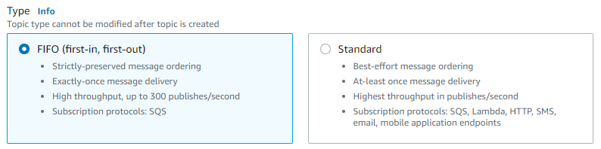

**Amazon SNS Clients**

There are two clients of SNS:

* Subscribers
* Publishers  
  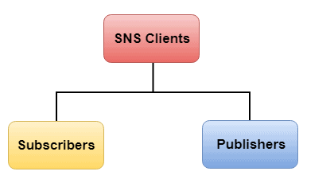

**Subscribers**

Subscribers receive the required message or notification over one of the supported protocols (Amazon SQS, email, Lambda, HTTP, SMS) when they are subscribed to the topic.

**Check Also:** Free [AWS Training](https://k21academy.com/aws-training-courses/) and Certifications

**Publishers**

Publishers are also known as producers, publishers communicate asynchronously with subscribers by producing and sending a message to a topic, which is a logical access point and communication channel.

**Benefits of AWS SNS**

* **Instantaneous Delivery:** It is based on push-based delivery. It is pushed once we publish the message on a topic and the message is delivered to multiple subscribers.
* **Inexpensive:** It is based on pay as you use the model, i.e. we need to pay only when we are using the resources with no up-front costs.
* **Flexible:** It supports multiple endpoints. Various endpoint types can receive the message over multiple transport protocols such as email, SMS, [Lambda](https://k21academy.com/amazon-web-services/aws-solutions-architect/aws-lambda-serverless-compute-service/), [Amazon SQS,](https://k21academy.com/amazon-web-services/aws-solutions-architect/aws-application-services/) HTTP, etc.
* **Ease of use:** It is a very simple service to use as the Web-based [AWS Management Console](https://k21academy.com/amazon-web-services/aws-management-console-walkthrough/) offers the effortlessness of the point-and-click interface.
* **Simple Architecture:**SNS is utilized to simplify the messaging architecture by offloading the message filtering logic from the subscribers and message routing logic from the publishers. Rather than receiving all the messages from the topic, SNS sends the message to subscriber-only of their interest.

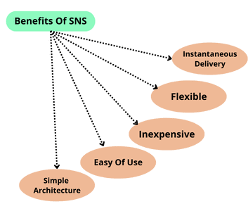

**Steps to Configure Amazon SNS**

In these steps, we are going to configure **Amazon SNS.** For creating AWS Free Tier Account click here: [AWS Free Tier Account](https://k21academy.com/amazon-web-services/aws-solutions-architect/create-aws-free-tier-account/)

**1)** Search **SNS** in the search bar and click on it. Afterwards, click on the **Topics** on the top left side of the Console and then Click on**Create Topic** to create a new topic.

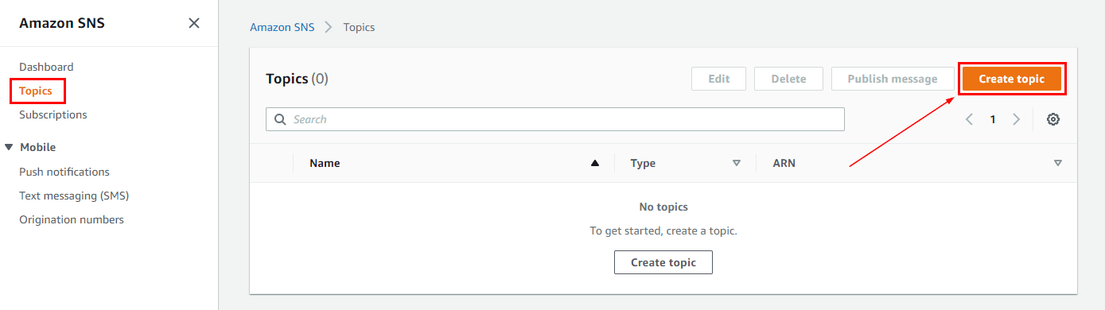

**2)** Select **Standard** type and Enter the Topic name. Scroll down and click on**Create Topic**.

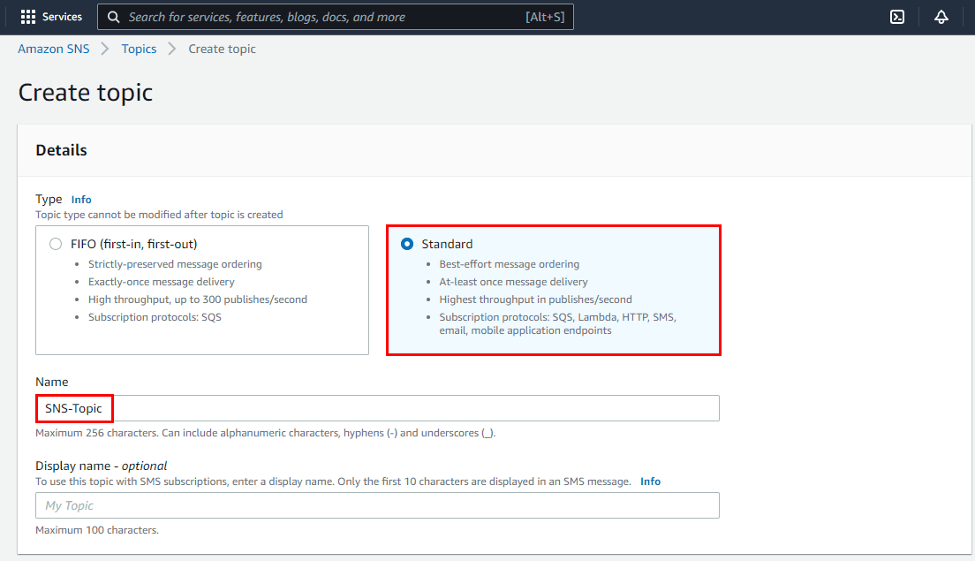

**3)** Now, the Topic has been created successfully. Scroll down and click on **Create Subscription**.

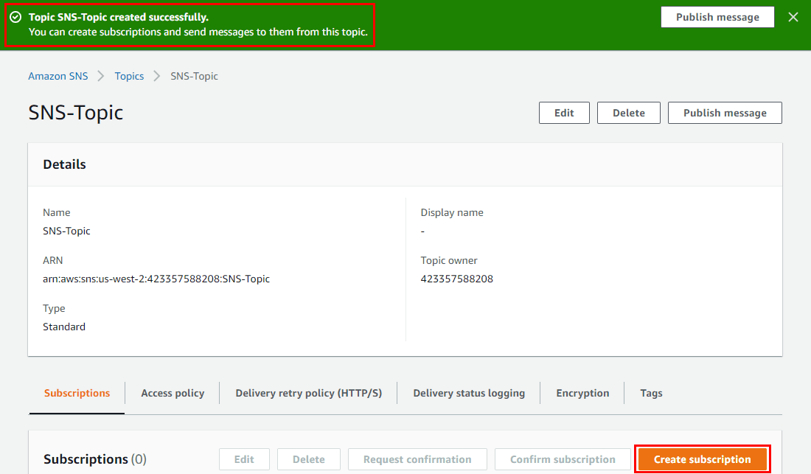

**4)** Under Protocol choose the **endpoint** as **Email** and enter the Endpoint address, click on **Create Subscription**. Now, the subscription will be created and the status of the subscription is pending.

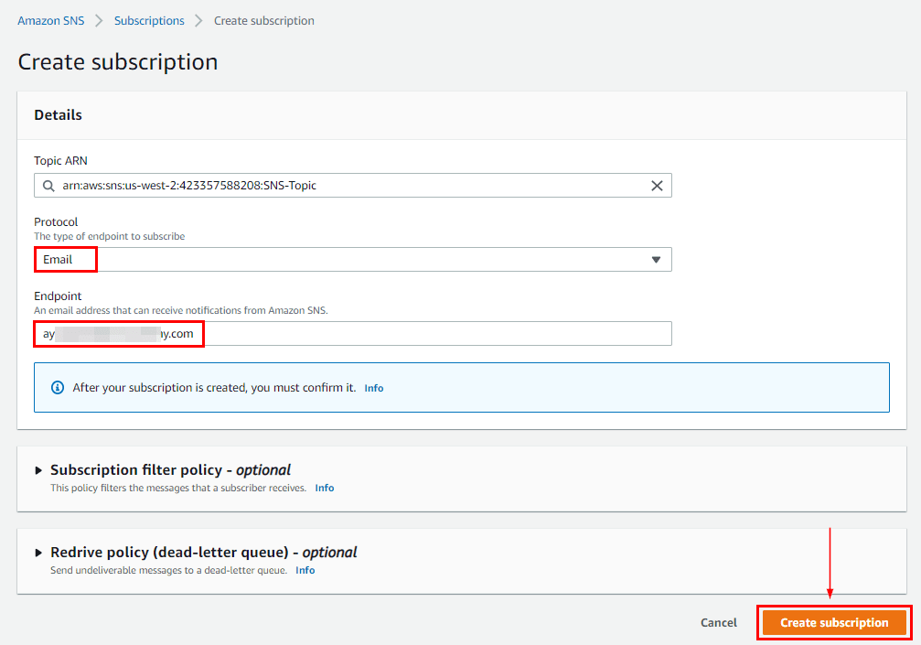

**5)** The email will be sent to the subscriber for confirmation of the subscription. The subscriber has to open the email and click on **Confirm Subscription**. After this subscription will be confirmed.

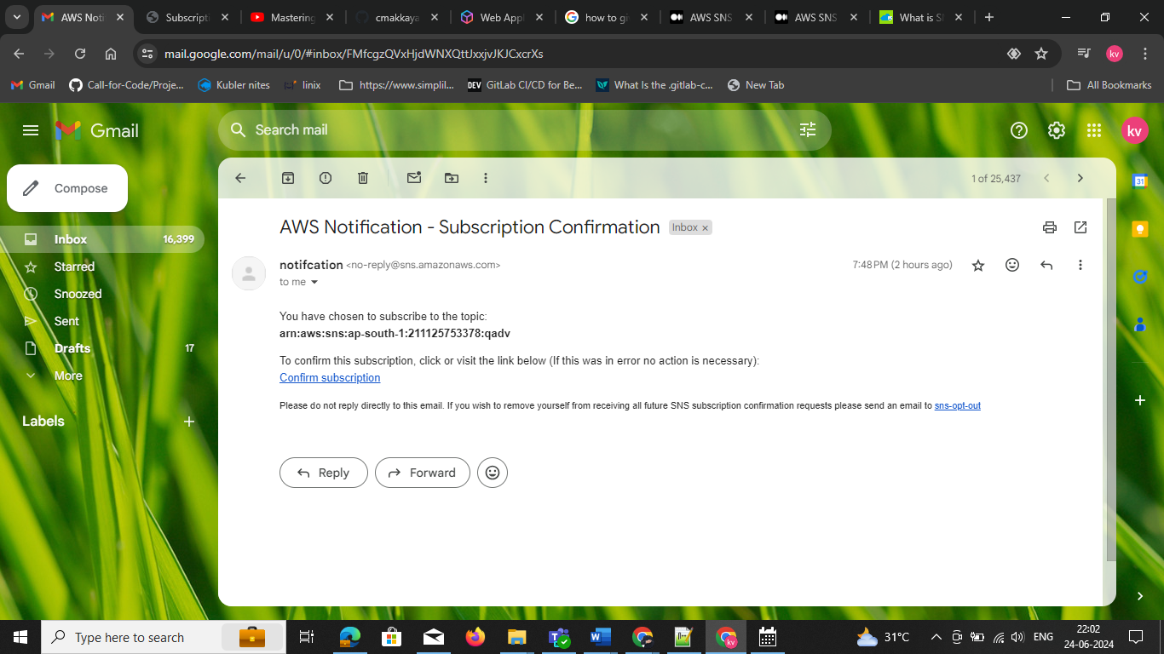

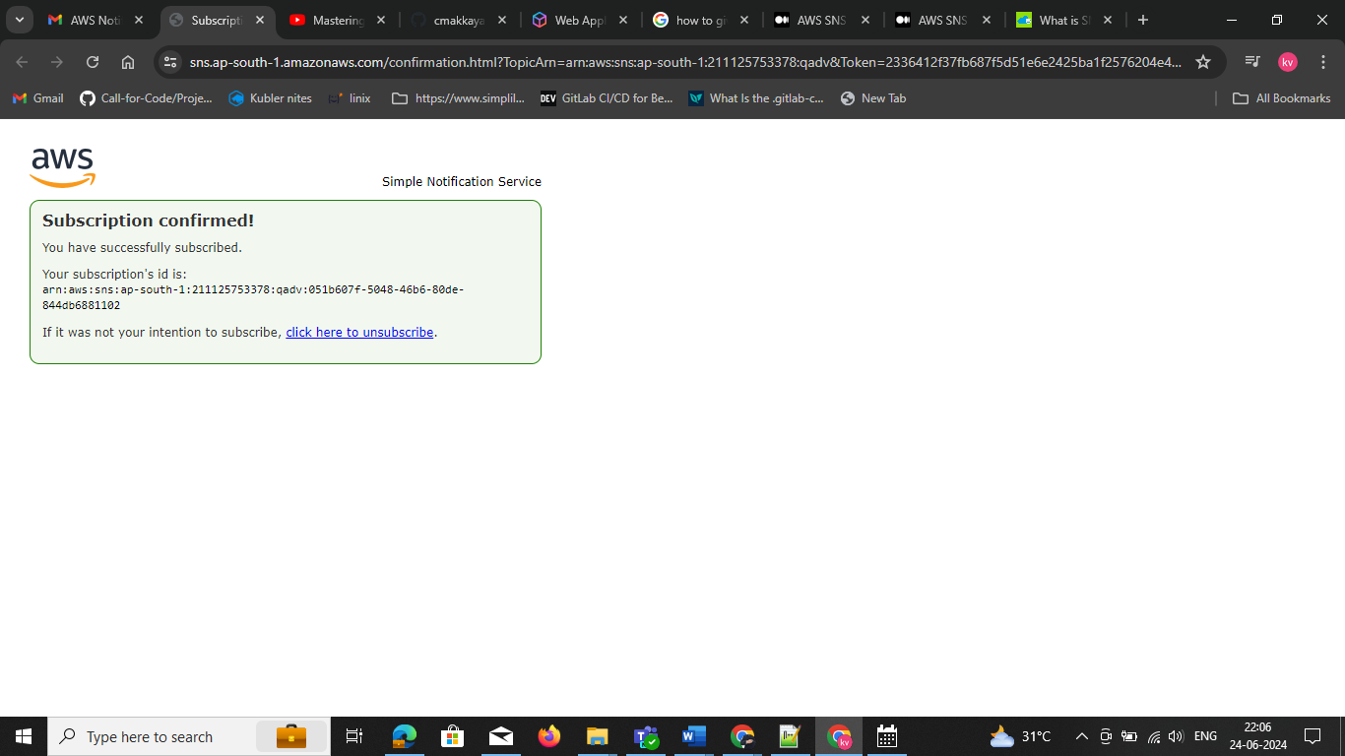

**6)** Now, the status of the subscription will be confirmed, and then click on the **Topic name**. After that click on **Publish Message**.

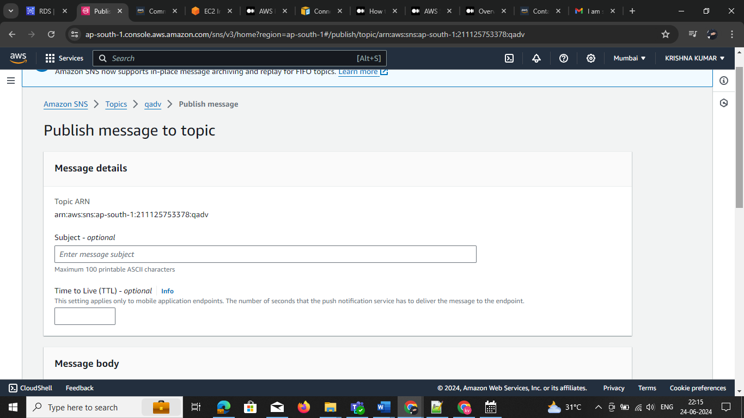

**7)** Enter the subject name and message body. Scroll down and click on **Publish Message.**

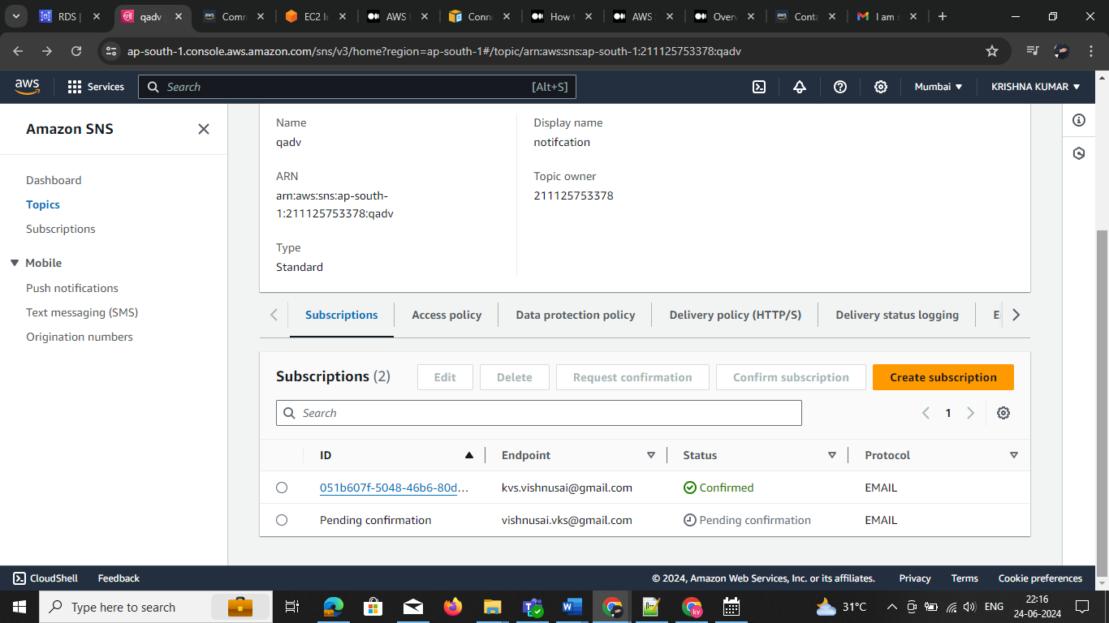

**8)** Now, the subscriber will receive the message on the mentioned email address.

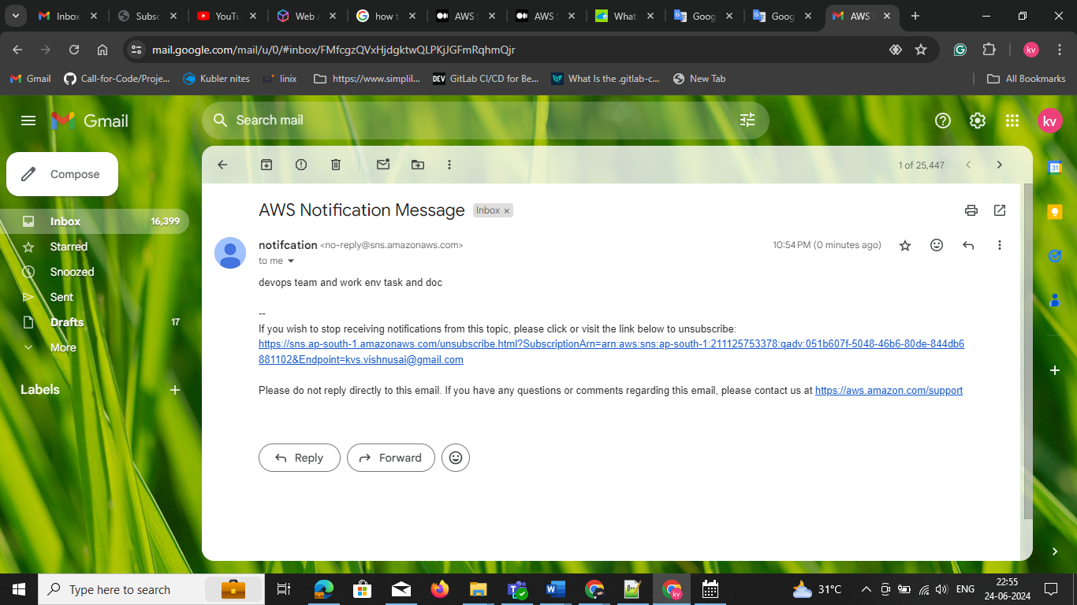

**AWS SNS Pricing**

By default, AWS SNS comes with a generous free tier, and it’s also inexpensive. There is no need for a subscription, you simply pay for what you use at the type of endpoint you choose. Each month we will get 1 million free mobile push notifications. Afterward, each delivered message is charged at $0.6 per million, it also depends upon the region of your recipient. Every time a 64KB portion of data is sent, it counts as one request for billing purposes. To illustrate, if a message with a 256KB size is sent, it would be charged as four requests.

**Amazon SNS Security**

* SNS provides encrypted topics to protect messages from unapproved and mysterious access. The encryption occurs on the server side.
* Amazon SNS supports VPC Endpoints via [AWS PrivateLink](https://k21academy.com/amazon-web-services/aws-privatelink/). We can utilize VPC Endpoints to privately publish messages to SNS topics, from a VPC, without traversing the public internet.
* Utilizing access policies, you have point-by-point control over which endpoints a topic allows, who is able to publish to a topic, and under what conditions.
* You can enable [AWS X-Ray](https://k21academy.com/amazon-web-services/aws-solutions-architect/aws-x-ray/) for your messages passing through Amazon SNS, making it simpler to trace and analyze messages as they travel through to the downstream services.